**Objective 1:** WAP to print Fibonacci series up to 10 numbers.

**PROGRAM 1**

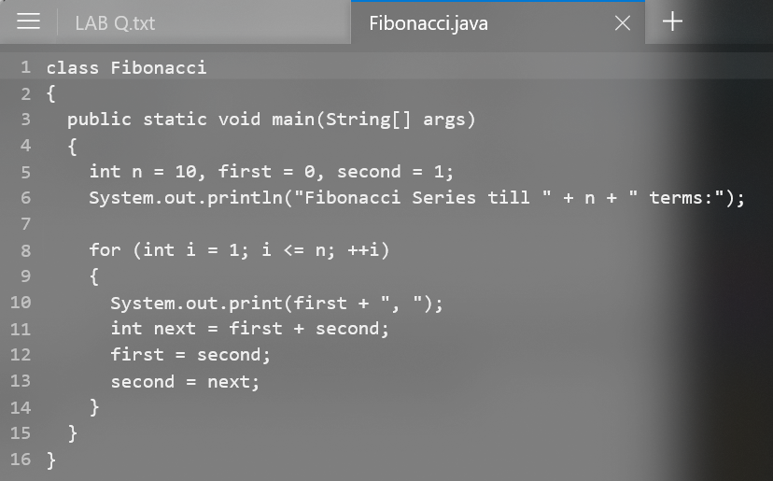

**OUTPUT**

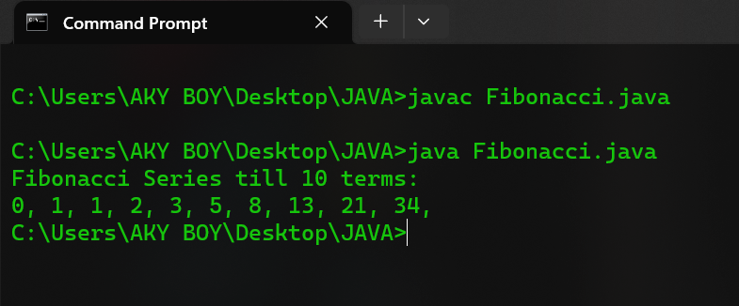

**Objective 2:** WAP to find the sum of all integers greater than 40 less than 250 that are divisible by 5.

**PROGRAM 2**

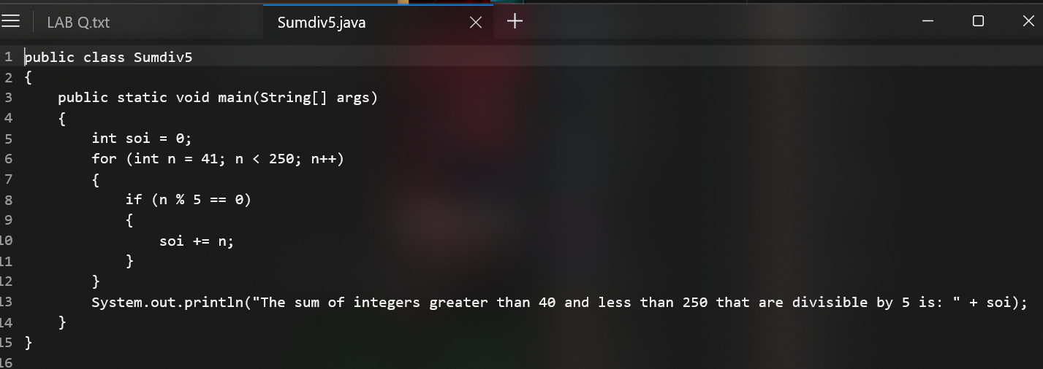

**OUTPUT**

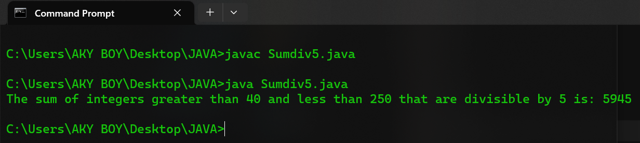

**Objective 3:** WAP calculate and display Simple interest for a given principal amount, rate of interest and time.

**PROGRAM 3**

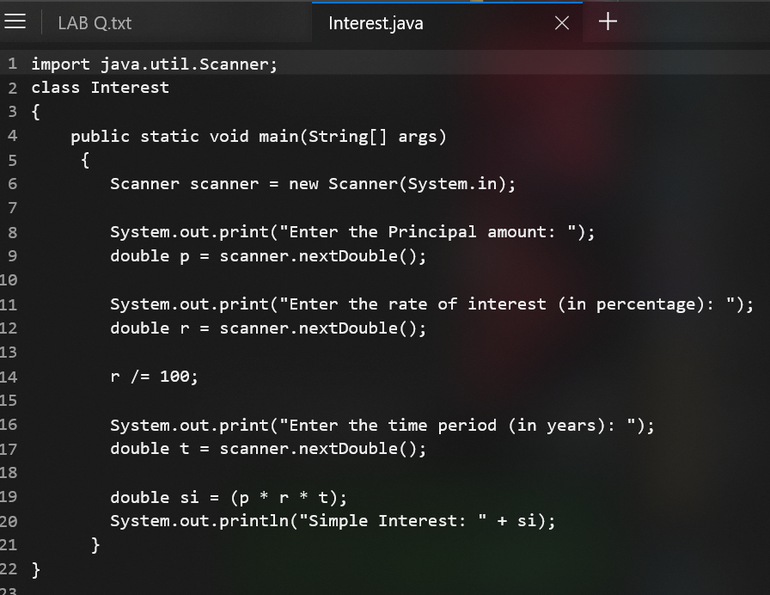

**OUTPUT**

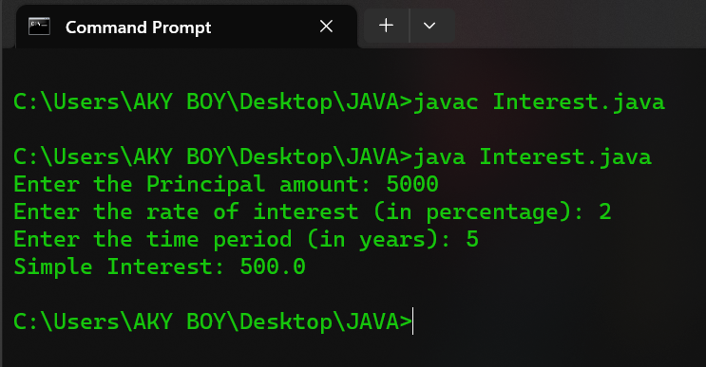

**Objective 4:** WAP that calculates and displays the sum of even and odd digits separately for a given positive integer.

**PROGRAM 4**

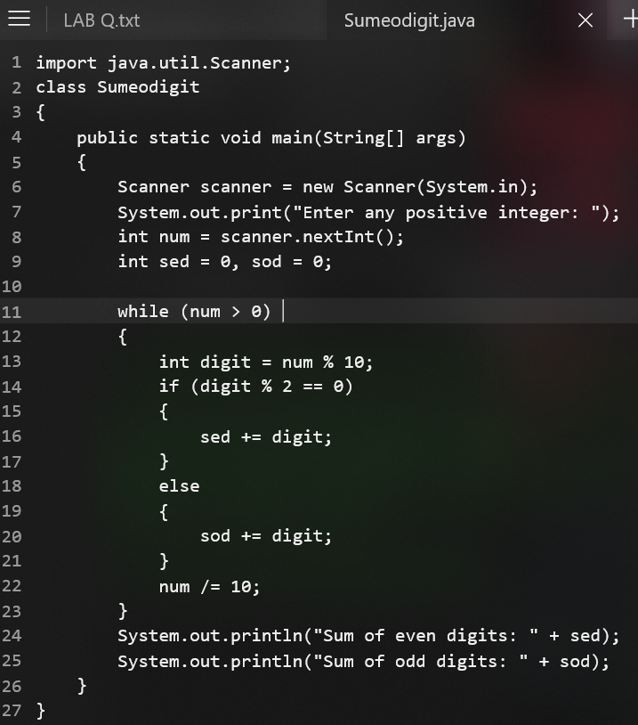

**OUTPUT**

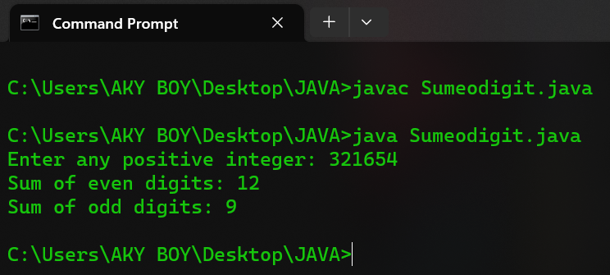

**Objective 5:** WAP that prints the following pyramid patters using following asterias.

**\***

**\* \***

**\* * \***

**\* * * \***

**\*  *   *  *   \***

**PROGRAM 5**

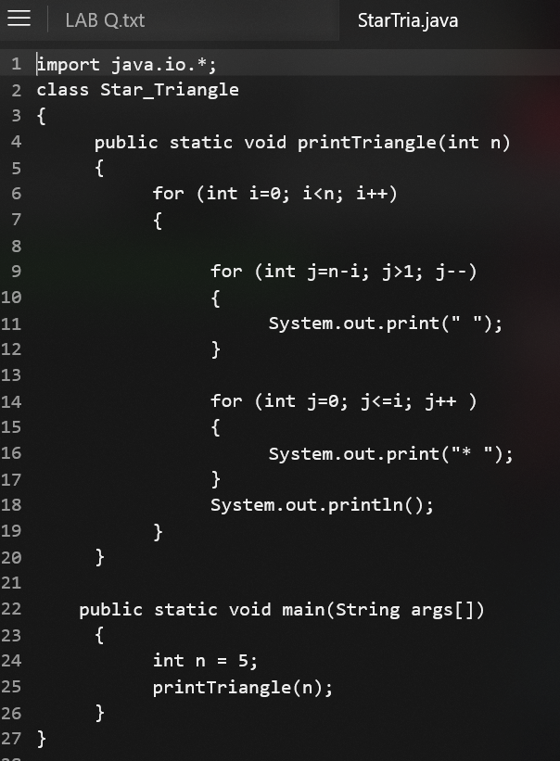

**OUTPUT**

